Macaroni and Cheese Healthy Recipe

No-Bake Macaroni & Cheese
WebMD Recipe from EatingWell.com
Not only is this ultra-creamy version of mac-and-cheese nearly as fast as the boxed variety, but your family will be able to pronounce every ingredient. If they aren't broccoli fans, substitute a frozen vegetable of your choice.
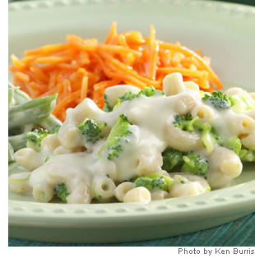
Servings: 4
Yield: 4 servings, 1 1/4 cups each
Total Time: 25 minutes
Prep Time: 20 minutes

Recipe Ingredients:
- 8 ounces whole-wheat elbow noodles (2 cups)
- 1 10-ounce package frozen chopped broccoli
- 1 3/4 cups low-fat milk, divided
- 3 tablespoons flour
- 1/2 teaspoon garlic powder
- 1/2 teaspoon salt
- 1/4 teaspoon ground white pepper
- 3/4 cup shredded extra-sharp Cheddar cheese
- 1/4 cup shredded Parmesan cheese
- 1 teaspoon Dijon mustard

Recipe Steps:
- Bring a large pot of water to a boil. Cook pasta for 4 minutes. Add frozen broccoli and continue cooking, stirring occasionally, until the pasta and broccoli are just tender, 4 to 5 minutes more.
- Meanwhile, heat 1 1/2 cups milk in another large pot over medium-high heat until just simmering. Whisk the remaining 1/4 cup milk, flour, garlic powder, salt and pepper in a small bowl until combined. Add the flour mixture to the simmering milk; return to a simmer and cook, whisking constantly, until the mixture is thickened, 2 to 3 minutes. Remove from the heat and whisk in Cheddar, Parmesan and mustard until the cheese is melted.
- Drain the pasta and broccoli and add to the cheese sauce. Return to the heat and cook, stirring, over medium-low heat, until heated through, about 1 minute.

Recipe Nutrition:
Per serving: 412 calories; 13 g fat (7 g saturated fat, 1 g mono unsaturated fat); 37 mg cholesterol; 56 g carbohydrates; 22 g protein; 7 g fiber; 640 mg sodium; 236 mg potassium
Nutrtion Bonus: Vitamin C (70% daily value), Calcium (40% dv), Fiber (27% dv), Vitamin A (25% dv), Magnesium (16% dv).
3 Carbohydrate Servings
Exchanges: 3 starch, 1 vegetable, 1/2 reduced-fat milk, 1 high-fat meat

Special Health Consideration(s):
High Calcium − Low Cholesterol − High Fiber
See More Nutrition Guidelines

http://www.webmd.com/food-recipes/no-bake-macaroni-and-cheese

